R.VISHNU VARDHAN - 2520090166

- Pwd

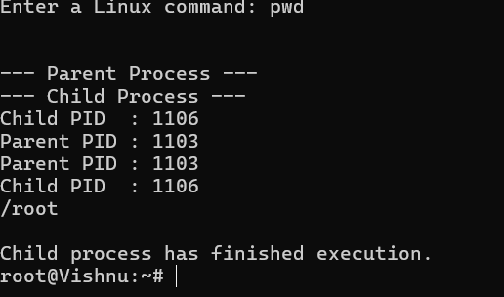

- Clear

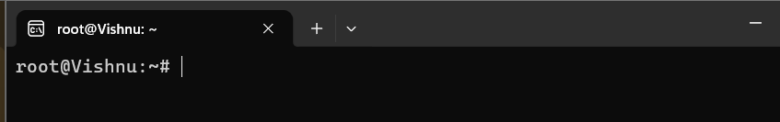

- History

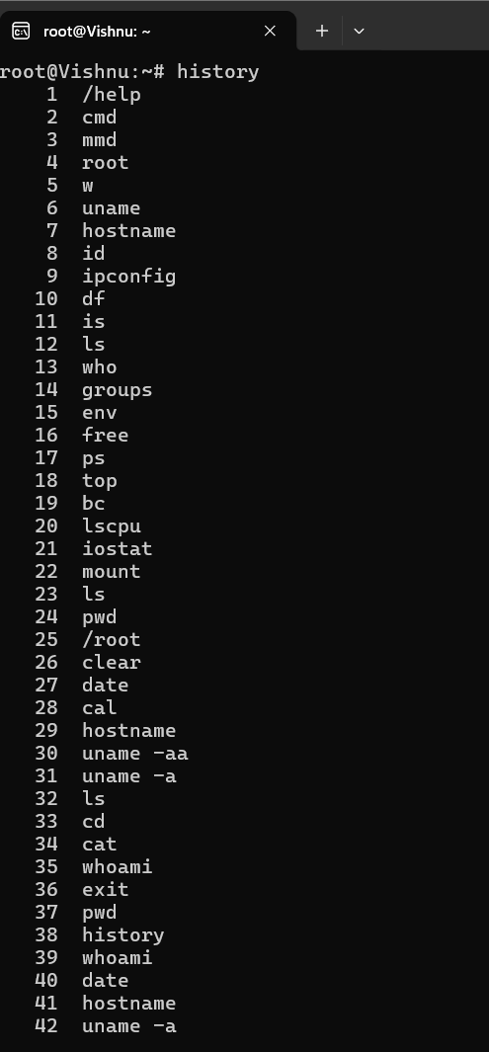

4)whoami

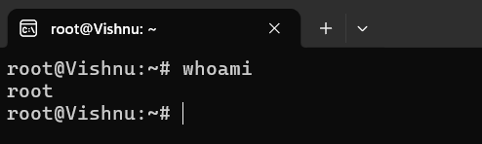

5)Date

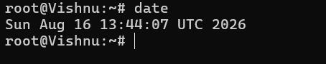

- Cal

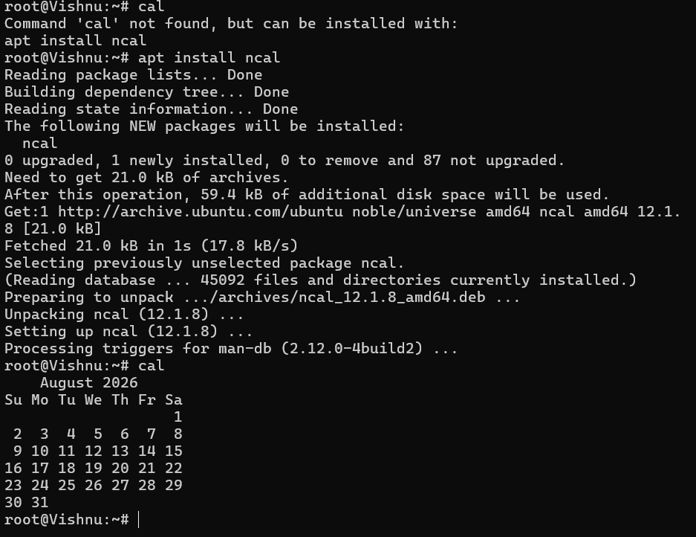

7)Hostname

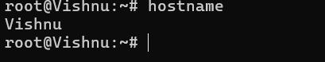

8)uname -a

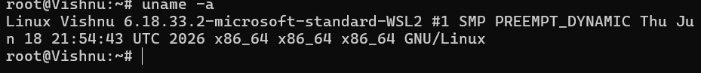

- Exit

